Lab: Basic Navigation Commands in Linux

Learning Objective
By the end of this lab you will be able to:
- Open a terminal and find “where you are” in the filesystem.
- List files (including hidden ones) and read basic details (size, permissions, dates).
- Move between folders with absolute and relative paths.
- Create a small practice folder structure and move around it confidently.
- Use built-in help so you can keep learning on your own.

Pre-Requisite
- Access to a Linux shell (any recent distro). Options:
  - A local Linux machine or VM, or WSL on Windows, or SSH into a Linux VM.
  - A terminal app (e.g., Terminal on macOS, Windows Terminal/PowerShell for WSL/SSH, or your distro’s terminal).
- No admin/root privileges needed.
Tip: Everything in this lab happens inside a folder in your home directory, so it’s safe.

Steps to Follow

Part A — Warm-Up: Open Your Terminal

Open your terminal and type:
echo "Hello Linux"; uname -a; echo "Shell:" $SHELL
You should see a greeting, system info, and which shell you’re using (e.g., /bin/bash or /bin/zsh).

Part B — “Where am I?” with pwd
Print your current working directory:
pwd
You’ll likely see something like /home/<username>. This is your home. The shortcut ~ also means “home”.
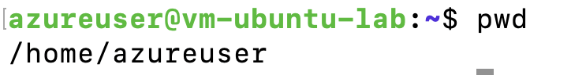

Part C — Create a Safe Practice Playground

Make a lab folder and jump into it:
mkdir -p ~/nav-lab

cd ~/nav-lab

pwd

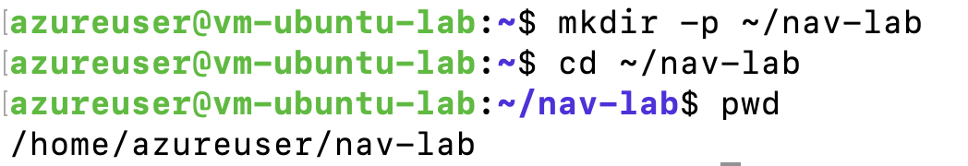

Create a small directory tree:
mkdir -p projects/app/{src,docs,logs}
mkdir -p sandbox
ls

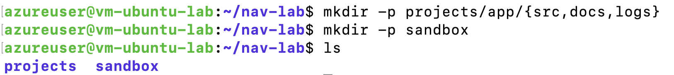

Create a few files:
touch projects/app/README.md projects/app/src/main.py sandbox/notes.txt

echo "Welcome to the lab" > WELCOME.txt

Part D — Listing Files with ls
- Basic listing:
ls

- Long (detailed) listing:
ls -l
You’ll see columns for permissions, owner, size, and modified date.
- Show hidden files (names starting with a dot):
ls -la

Part E — Moving Around with cd
Go into a directory (relative path):
cd projects/app

pwd

Go up one level (parent):
cd ..

pwd

Go home from anywhere:
cd ~

pwd

Go back to the previous location:

cd -
Jump with an absolute path (starts with /):
cd /etc

pwd

Return to the lab with absolute or shortcut:
cd ~/nav-lab
Cheat codes:
- . means “current directory”
- .. means “parent directory”
- ~ means “home directory”
- cd - toggles between last two locations

Part F — See What’s Here (and Only What You Need)
List recursively:
ls -R

List by time (newest last):
ls -lt

Use globs (wildcards):
ls *.txt

ls p*

Part G — Peek Inside Files
Print contents:
cat WELCOME.txt

Page through (space to go down, q to quit):
less WELCOME.txt
cat is quick for small files; less is comfy for longer ones.

Part H — Hidden Files & Why They Matter
Create a hidden file:
echo "secret" > .hidden-config

Compare:
ls

ls -a

Hidden files appear only with -a. Many app configs live here.

Part I — Paths: Absolute vs Relative (Hands-On)
From ~/nav-lab, run:
cd projects/app/src

pwd

Relative path back to nav-lab:
cd ../../..

pwd

Absolute path straight to src again (change yourname if needed):
cd /home/$(whoami)/nav-lab/projects/app/src

pwd

Absolute paths are like full street addresses. Relative paths are “turn left at the corner” from where you are.

Part J — Clean Up (Optional but Recommended)
Stay in home before deleting:
cd ~

# safer: interactive prompt before recursive delete

rm -rI ~/nav-lab
⚠️ Be careful with rm -r. The -I (capital i) asks before deleting more than a few files.

